
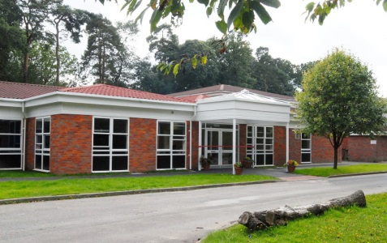
We have made this for you to share with your family and friends to help you get ready for Year 6.

Welcome
to
Year 6

Class Teacher
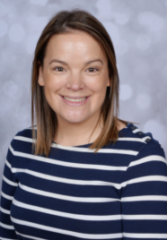

Ms Brian


These are the other adults who will be supporting in Year 6


Mrs Loyal

Mrs Middlemist

Please note, whilst we aim to provide consistency by maintaining the same support staff throughout the school year, there may be occasions where staffing changes are necessary to support the needs of children across the school. We will always strive to minimize disruption and ensure continuity of care and support.

This is the Year 6 classroom
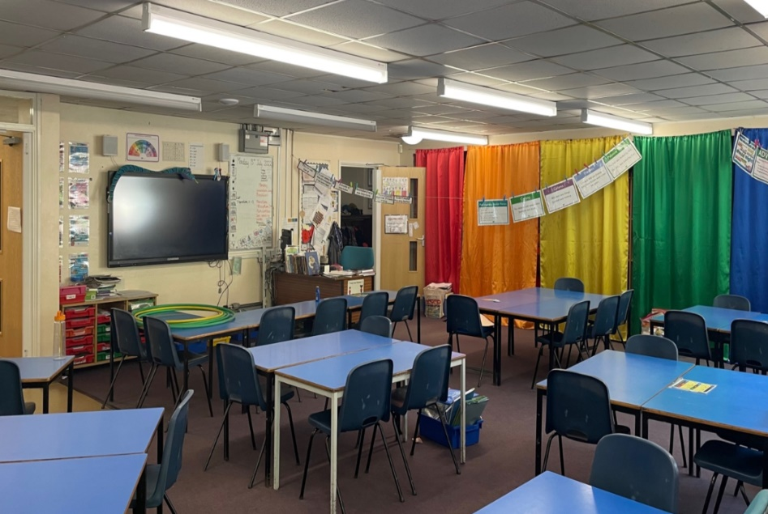

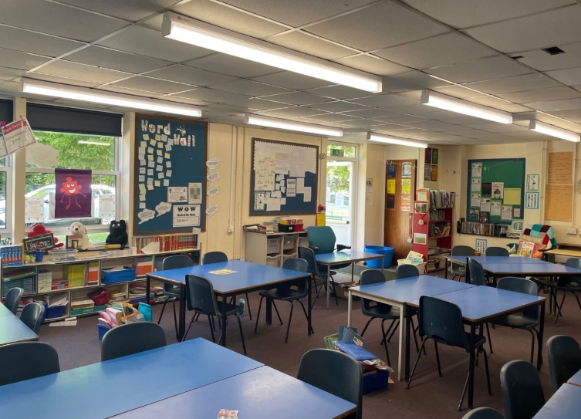

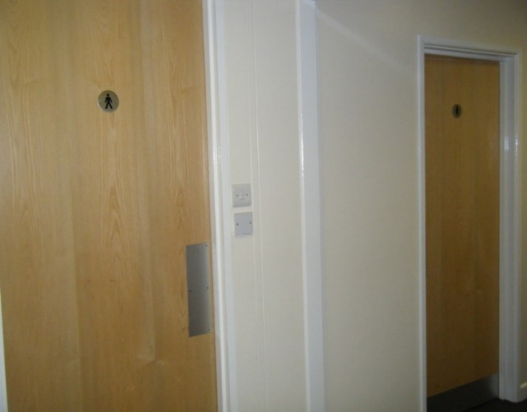
These are the Year 6 toilets

