
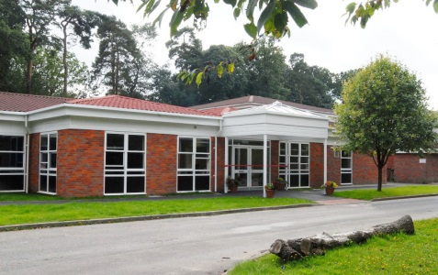
We have made this for you to share with your family and friends to help you get ready for Year 5.

Welcome
to
Year 5
Year 5 Class Teacher



Miss Raynsford

These are the other adults who will be supporting in Year 5




Mrs Loyal
Mrs Reading Ms Trentini

Please note, whilst we aim to provide consistency by maintaining the same support staff throughout the school year, there may be occasions where staffing changes are necessary to support the needs of children across the school. We will always strive to minimize disruption and ensure continuity of care and support.

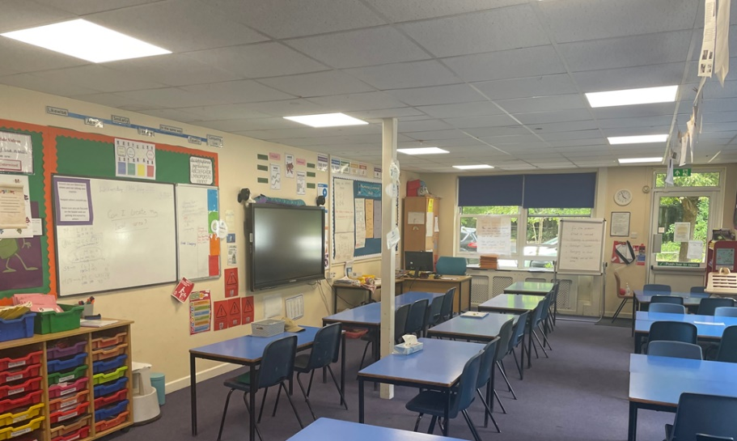
This is the Year 5 classroom

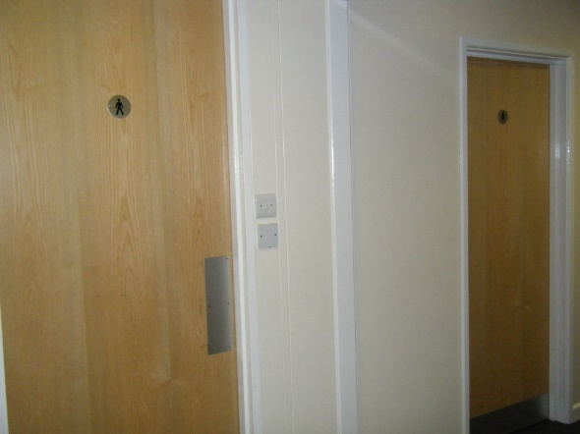
These are the Year 5 toilets
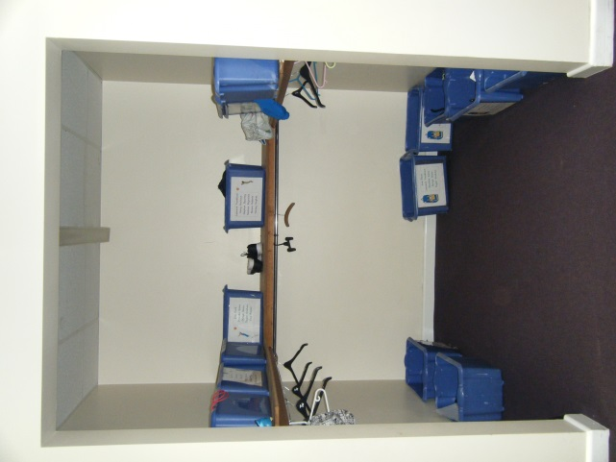

This is where Year 5 hang up their coats and put their PE kits and bags
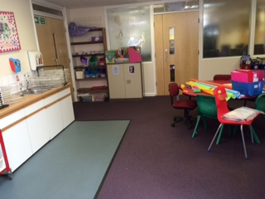
This is the shared learning area outside the Year 5 classroom

