
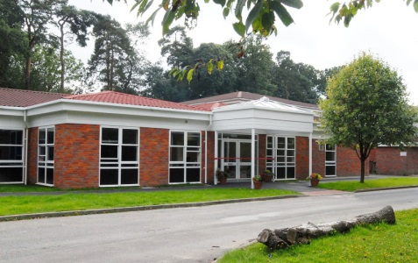
Welcome
to
Year 4

We have made this for you to share with your family and friends to help you get ready for Year 4.

You have two class teachers in Year 4

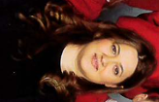
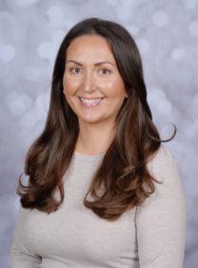

Mrs Hinta on
Monday, Tuesday and Wednesdays

Miss Currie on
Thursday and Fridays

These are the other adults who will be supporting in Year 4
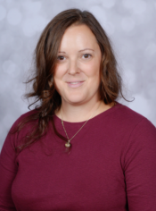
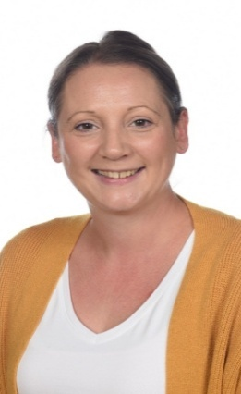


Mrs Filippini

Mrs Middlemist

Ms Trentini

Please note, whilst we aim to provide consistency by maintaining the same support staff throughout the school year, there may be occasions where staffing changes are necessary to support the needs of children across the school. We will always strive to minimize disruption and ensure continuity of care and support.

This is the Year 4 classroom
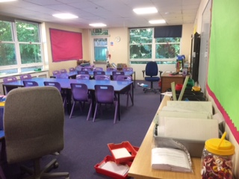

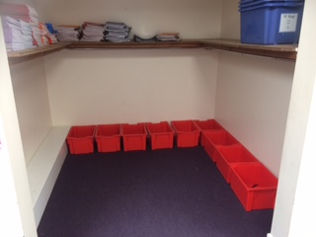
These are the Year 4 toilets
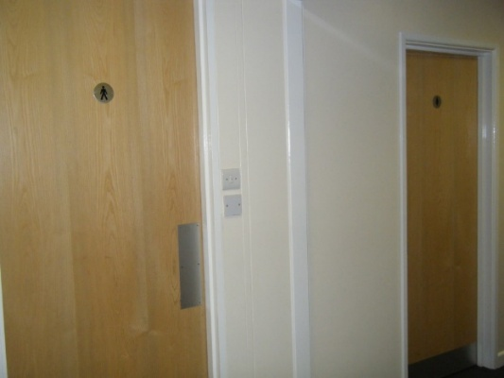

This is where Year 4 hang up
their coats and put their PE kits and bags
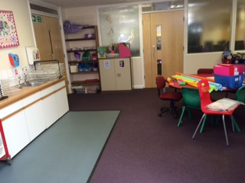

This is the shared learning area outside the Year 5 classroom

