
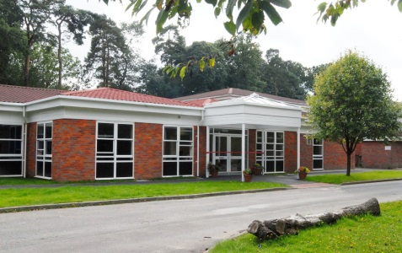

We have made this for you to share with your family and friends to help you get ready for Year 3.

Welcome
to
Year 3

This is the Year 3 class teacher



Hello, I’m Miss Costello

Hello, I’m Mrs Low
These are some of the other adults who will be supporting in Year 3

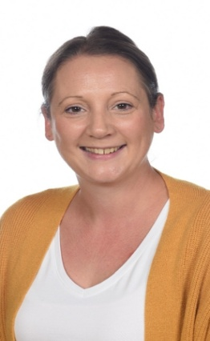


Ms Trentini Miss Smith Mrs Middlemist

Please note, whilst we aim to provide consistency by maintaining the same support staff throughout the school year, there may be occasions where staffing changes are necessary to support the needs of children across the school. We will always strive to minimize disruption and ensure continuity of care and support.

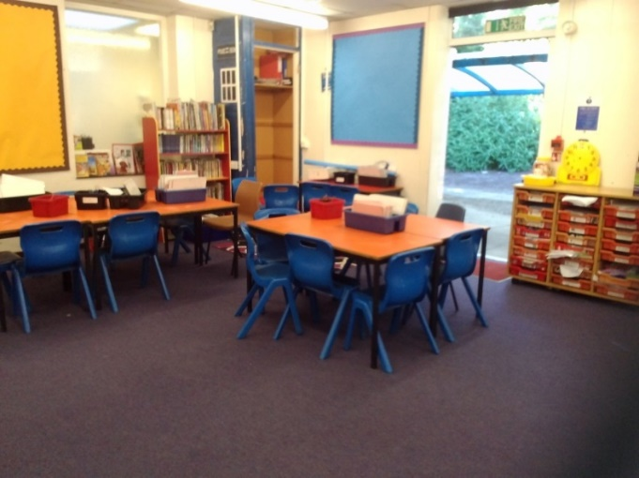
This is the Year 3
classroom

This is the door you will come in through and the outdoor shelter

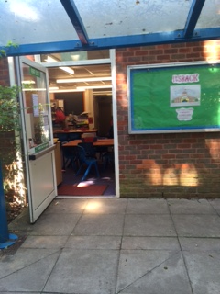
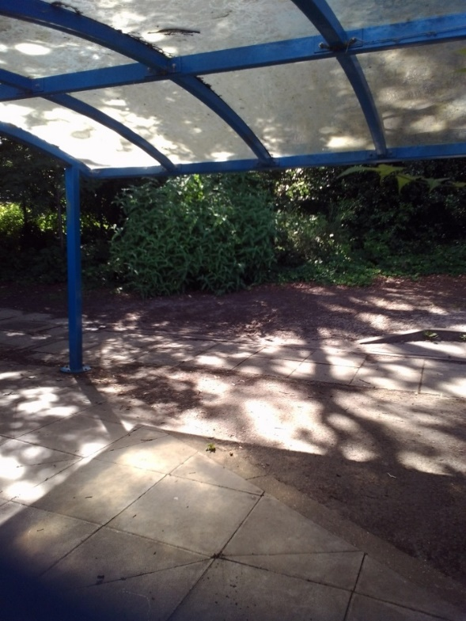

This is the Year 3 toilet area
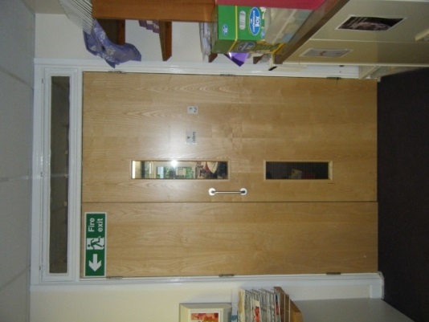
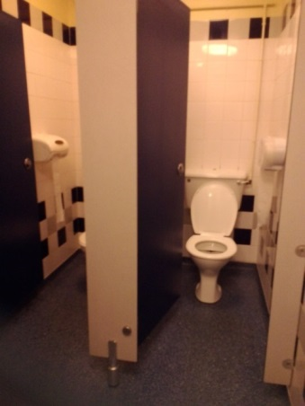

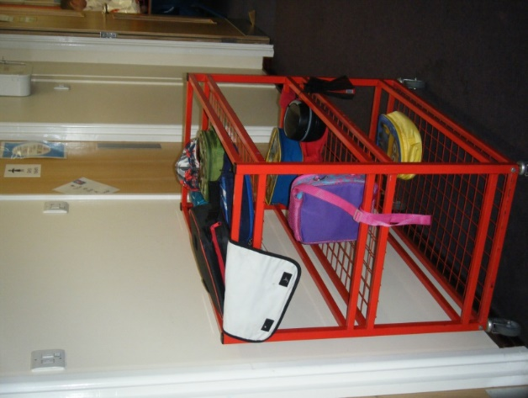
This is where the lunch trolley is kept

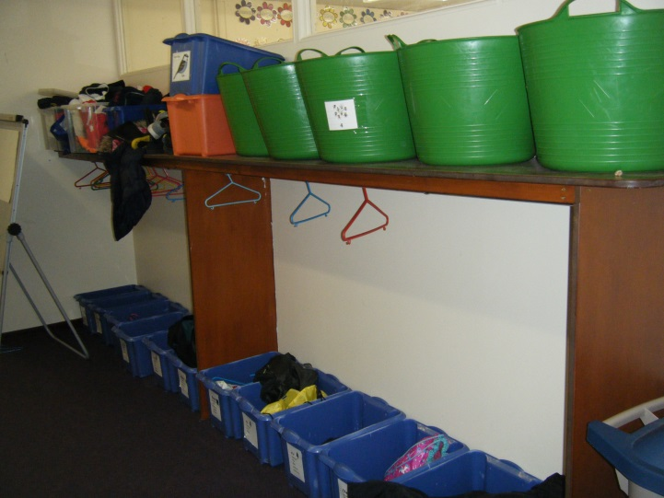
This is where Year 3 hang up their coats and put their PE kits and bags

