
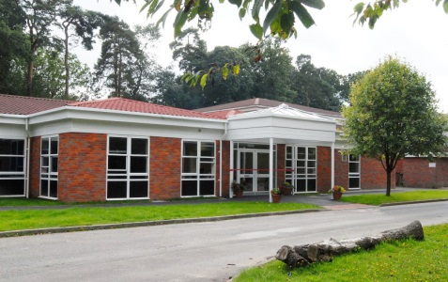
Welcome
to
Year 2 Class
We have made this for you to share with your family and friends to help you get ready for Year 2.
We hope you enjoy it!
This is the Year 2 class teacher


Hello, I’m Mr Jones.

Mrs Reading
will be teaching on one afternoon a week

These are the other adults who will be supporting in Year 2
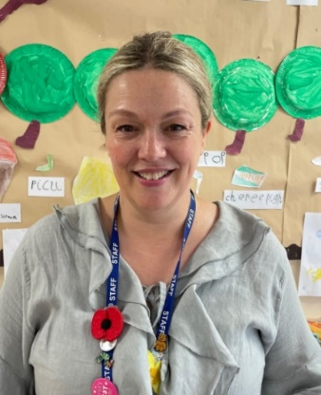


Mrs Barker Mrs Low
Please note, whilst we aim to provide consistency by maintaining the same support staff throughout the school year, there may be occasions where staffing changes are necessary to support the needs of children across the school. We will always strive to minimize disruption and ensure continuity of care and support.
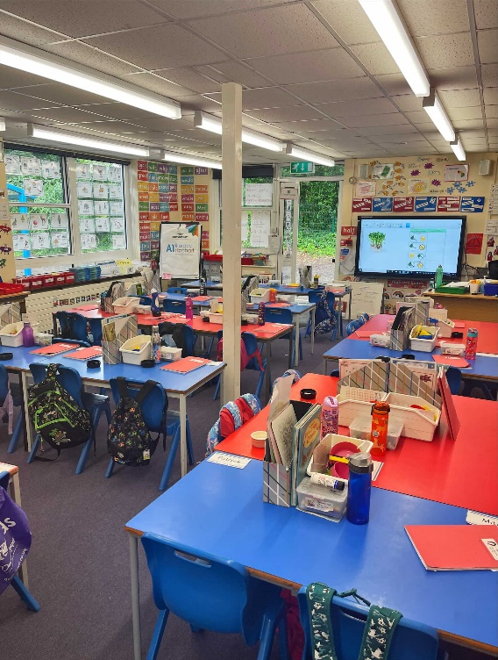
This is the Year 2 classroom.

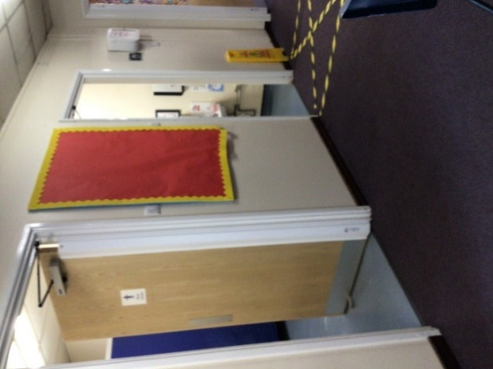

These are the Year 2 toilets.

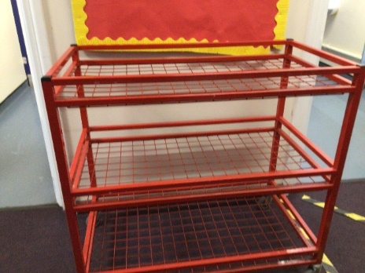

Lunchboxes are kept on the lunchbox trolley outside the classroom.
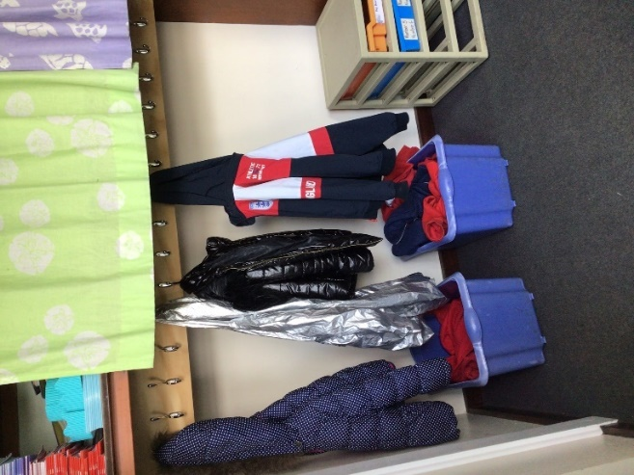
This is where Year 2 hang up their coats

