
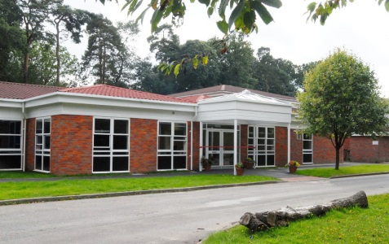
Welcome
to
Year 1 Class
We have made this for you to share with your family and friends to help you get ready for Year 1.
We hope you enjoy it!

This is the Year 1 class teacher


Hello, I’m Miss Gorrod

These are the other adults who will be working in Year 1
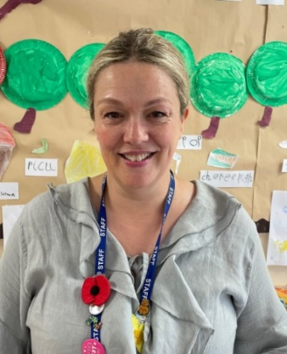
Hello, I’m
Mrs Low



I’m
Mrs Reading


Hello, I’m
Miss Smith

Please note, whilst we aim to provide consistency by maintaining the same support staff throughout the school year, there may be occasions where staffing changes are necessary to support the needs of children across the school. We will always strive to minimize disruption and ensure continuity of care and support.
This is the Year 1 classroom.
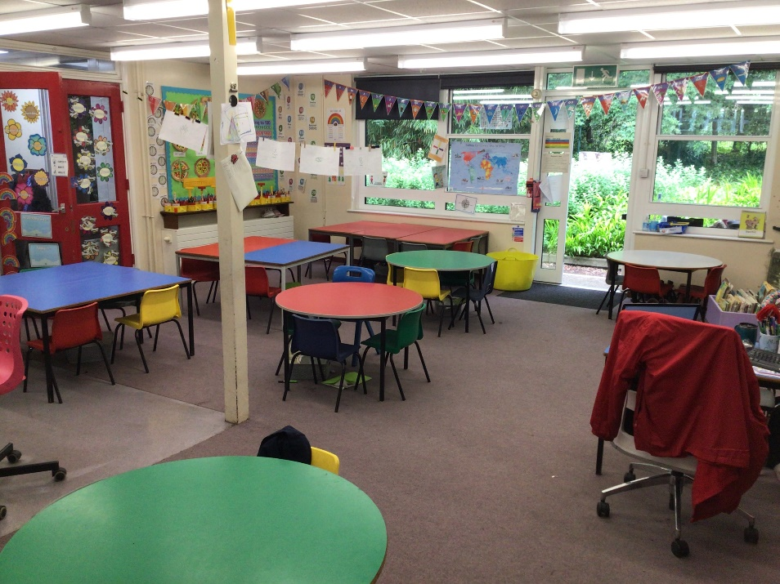

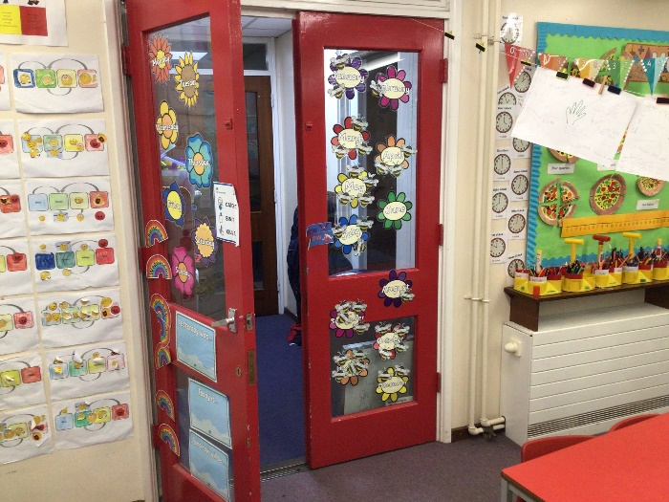
The Year 1 toilets are through these red doors.

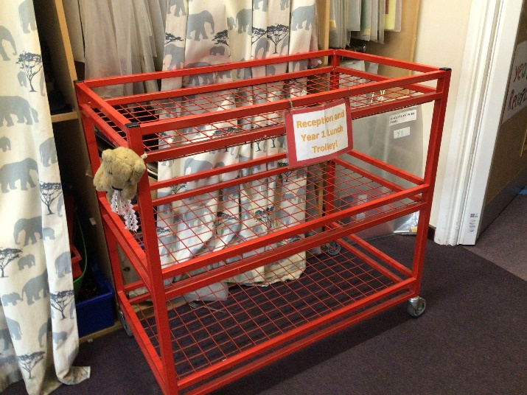
Put your lunchbox on the Reception and Year 1 lunchbox trolley.

This is where Year 1 hang up their coats and put their PE kits and bags.
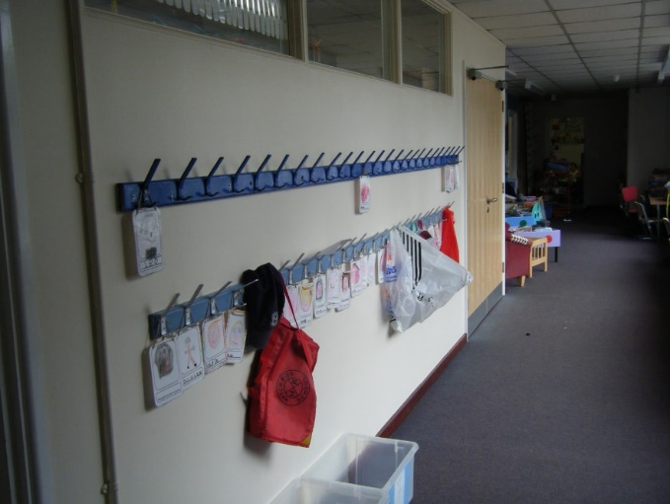

This is where you keep your bottle and snacks.
