Hatch Ride Primary School Pupil premium strategy statement and report – 2025-2026

This statement details our school’s use of pupil premium funding to help improve the attainment of our disadvantaged pupils.

It outlines our pupil premium strategy, how we intend to spend the funding in this academic year and the effect that last year’s spending of pupil premium had within our school.

School overview
Detail | Data
School name | Hatch Ride Primary School
Number of pupils in school | 201
Proportion (%) of pupil premium eligible pupils | 4% - 8 pupils
Academic year/years that our current pupil premium strategy plan covers | 2025-2026
Date this statement was published | December 2025
Date on which it will be reviewed | October 2026
Statement authorised by | J Sparrowhawk
Pupil premium leads | J Sparrowhawk and Helen Flavin
Governor / Trustee lead | G Hayward
Funding overview
Detail | Amount
Pupil premium funding allocation this academic year | £21,125
Recovery premium funding allocation this academic year | 0
Pupil premium funding carried forward from previous years (enter £0 if not applicable) | 0
Total budget for this academic year  If your school is an academy in a trust that pools this funding, state the amount available to your school this academic year | £21,125

Part A: Pupil premium strategy plan

Statement of intent

At Hatch Ride Primary School, we believe that all our pupils are entitled to an education where they can make progress and achieve their full potential, irrespective of their background or any challenges they may face. By providing a high quality broad and balanced curriculum that promotes self-respect and respect for others, our pupils become confident individuals and happy learners who live fulfilling lives and are able to make a successful transition into adulthood.
We follow evidence-based research (EEF) and as a result, our key principles of this strategy are to ensure that:
- Quality first teaching and learning opportunities meet the needs of all of our pupils.
- Appropriate targeted provision is made for pupils who belong to vulnerable groups, so that identified needs are adequately assessed and addressed.
- There is a recognition that not all pupils who are disadvantaged are registered or qualify for free school meals.
- Pupil premium funding will be allocated following a needs analysis which will identify priority classes, groups or individuals. Staffing structures will be agile to meet the needs of individuals and cohorts.
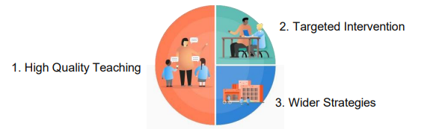

We recognise that having a great teacher makes a huge difference and our priority is to ensure that all our pupils, including those in receipt of the Pupil Premium Grant, receive Quality First teaching. Therefore, a significant amount of our Pupil Premium budget is spent on our teaching staff budget to ensure the recruitment and retention of high-quality teachers. We also use some of our Pupil Premium Funding to renew our intervention subscriptions to fill gaps in learning and raise attainment with a specific focus on Pupil Premium pupils.

We recognise that a ‘little and often’ approach for securing basic skills can have a huge impact and so we also invest heavily in our team of Learning Support Assistants to ensure that disadvantaged pupils have access to regular reading and other targeted work to ensure our children reach their full potential.

As a one-form entry school, our PP children do not naturally form groups with similar challenges. Their additional support is often
individualised.

Our PP children with an underlying learning difficulty require a more regular approach to their intervention in order to ensure they make good progress for them and meet their personalised targets and we utilise our most experienced Learning Support Assistants for this. For other more complex learning difficulties, we use funding to provide training for all staff to help us meet needs.

Our aim is to promote a sense of belonging and wellbeing for all pupils. We especially recognise how those pupils who are categorised as looked after, may have experienced more exposure to ACEs. As a result, we have provided staff with training regarding ACEs and supporting children who have experienced adverse childhood experiences. We have 2 fully trained Nurture Support assistants with dedicated time in the school timetable, one of whom has received additional training related to attachment-based games. Our Healthy Minds initiative has been well embedded since 2018, with the emotional barriers to learning of our Pupil Premium Pupils’ at the forefront of our minds when planning the content. This is an ongoing initiative which we recognise as crucial to enable all our children to reach their academic potential. The theme in May 2026 will be focused around the theme of belonging. In addition to this, we currently have 2 BACP registered counsellors working with the school on a weekly basis, one whom has specialisms in adoption and neurodiversity.

Attendance is a key factor for all children to achieve their full potential and not missing essential learning time. The use of clubs and after school clubs to support attendance is also supplemented by the Pupil Premium Grant.

Challenges

This details the key challenges to achievement that we have identified among our disadvantaged pupils.
Challenge number | Detail of challenge
1. | Cognition and learning  In Autumn 2025 assessments have shown that 6/8 of our disadvantaged children are working below the academic level of their peers.  Writing  As a school we are focusing on improving the quality of writing across all year groups, with a specific focus on disadvantaged children.  Reading and phonics  Children may not be reading regularly at home for a number of reasons or have delayed comprehension skills.
2. | Early attachment and Adverse Childhood experiences  We are aware of a number of ACEs experienced by our children and there may be more which we do not have specific details of, particularly for those who are LAC or PLAC. These children may exhibit insecure attachment styles and require support from secondary attachment figures.  Other challenges include family breakdown/conflict, illness of family members, bereavement and substance misuse within the home.
3. | Attendance and punctuality of some individuals and EBSA. Our FSM attendance is higher than national average, although to support the attendance of a number of children, we need to put in place support to reduce anxiety and support their emotional regulation.
4. | Nutrition  Some children with limited diets due to sensory needs and others due to financial pressures at home.

Intended outcomes
This explains the outcomes we are aiming for by the end of our current strategy plan, and how we will measure whether they have been achieved.
Intended outcome | Success criteria
To improve attainment of Pupil Premium and disadvantaged pupils in Phonics, Reading, Writing and Maths | Children, unless identified as having a specific Special Educational Need in Cognition and Learning leading to a barrier to reaching expected, will have made expected or better progress and will be working at least within Age Related Expectations  Pupil premium pupils in Year 1 will pass the phonics screener  Children who do not pass the phonics screener (at all or well) will improve score year on year  Pupil premium pupils at end of KS1 will reach ARE in R, W and M  Pupil premium pupils at end of KS2 will reach ARE in GPS, R, W and will make progress in line or better than their targets.  Children will show small steps of reading progress evidenced through completing ‘Lexia’ levels and moving through reading book bands.
Pupil Premium children will have a good level of attendance | Attendance of PP children will be good (95%+)  They will have full uniform and resources needed  PP children have a key person selected by them who regularly checks in
To support positive attachments in school and strategies for emotional regulation | Children ask for time with a trusted adult through nurture sessions or counselling drop ins.  A robust referral system for access to onsite counselling  Pupils and parents report positive impact after period of counselling sessions
For all Pupil Premium pupils to have the opportunity to access wider, enriching extra-curricular opportunities | All Pupil Premium children will have taken part in at least one club/extra-curricular activity this year  PP children will be put forward for other opportunities such as sport and music events or any other offered off-site as part of a small group  PP children attend all trips, visits and visitors
For Pupil Premium children to have access to a healthy, balanced diet in school and to have the opportunity to explore a range of food choices which may be outside of their usual diet. | Children to be offered the option of a balance school lunch, with access to the salad bar, to expand food options and foods to try.  For pupil premium children to be able to discuss what makes a healthy, balanced diet and be exposed to additional food preparation and cooking experiences.

Activity in this academic year
This details how we intend to spend our pupil premium this academic year to address the challenges listed above.

High Quality Teaching
Budgeted cost: £17,800
Activity | Evidence that supports this approach | Challenge number(s) addressed
LSA’s in classes of Pupil Premium children for at least half of the school day |  | 1,2 and 3
Hatch Ride is one of 130 schools participating in an EEF trial of Literacy Tree in years 2 and 5.  We are also funding Literacy Tree planning and resources in years 1,3,4 and 6 so that children in all KS1 and KS2 classes can benefit | Literacy Tree and EEF Writing Roots Trial  Literacy Tree ‘We are working with the Education Endowment Foundation and independent evaluators, RAND Europe and the University of Leeds on an national trial testing the impact of applying a book-based approach to teaching writing, using diverse, high-quality children’s literature to engage Primary-aged pupils in writing’.  Trail period - this academic year with endline assessments due to be completed in July 2026. The EEF evaluation report is due to be published in Spring 2027. | 1
Maths Mastery  Mastering Number (3 day teacher cost) | Professional development to support the implementation of evidence-based approaches - for example, programme or mastery based approaches to teaching or feedback | 1
PiXL testing being used across Years 1-6  Additional Implementation of in-house SEN assessments | PiXL supports the tiered approach (EEF).  The Sutton Trust found that, ‘The effects of highquality teaching are especially significant for pupils from disadvantaged backgrounds over a school year, these pupils gain 1.5 years’ worth of learning with very effective teachers.’  Keeping track of those children who are PP and SEND  YARK – accuracy, rate and comprehension  Helen Arkell – spelling age  Sandwell – early numeracy  Identifying gaps and weaknesses to put sharply focused support or intervention in place early | 1
Nurture time given for individuals and groups with trained LSA’s, after referral | Budget suggests that there is a systemic issue where we are not targeting SEMH of pupils to enable them to thrive and develop emotional competencies and good mental health. Pan Berkshire Breaking Through Barriers Conference 2018 | 2
Adverse Childhood Experiences (ACEs) training for all new staff  Subscription to TES Develop programme for all staff including governors | Creating a whole-school, proactive approach to understanding the needs of any LAC is important to help achieve positive outcomes.(Children’s and Young Persons Act 2008) | 2

Targeted academic support
Budgeted cost: £2118
Activity | Evidence that supports this approach | Challenge number(s) addressed
Lexia Reading Core5 | EEF promising programme  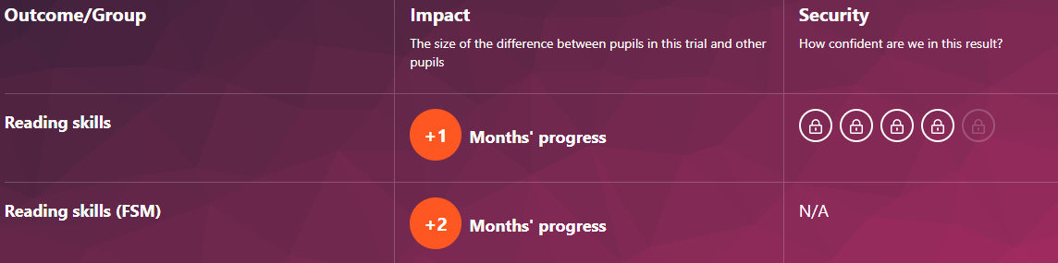  The findings indicate that at the end of Year 2, children who received the Lexia programme excelled in reading, made one months of additional progress in comparison with their peers in the control group. Also, children eligible for Free School Meals (FSM) who took participated in the programme made an additional two months of progress compared to children eligible for FSM who did not receive the intervention.  Crucially, they [the results] also indicate that the programme may be more effective for children eligible for FSM, which means it shows early signs of potential as an attainment gap closer. | 1
School BACP accredited counsellor with qualifications in working with looked after children and autism  In addition, another level 5 trained counsellor in school. | The benefits of school-based counselling School counselling has evolved over the years and can be beneficial in a number of ways.  For example, it can:  1. Reduce the psychological distress that children and young people experience as a result of facing a range of challenges and difficulties  2. Offer a dedicated and safe space to talk about difficulties independently and without judgment  3. Help children and young people learn effective strategies and support them in becoming more resilient  4. Help develop positive self-esteem, confidence, social skills and good mental health  5. Improve engagement in learning  6. Reduce the stigma around mental health  7. Provide insight and guidance for school staff on supporting children and young people  8. Facilitate an important link between school, families and other specialist agencies.  https://www.bacp.co.uk/media/19168/bacp-school-based-counselling-essential-guide-november-2023.pdf  There is robust research evidence that school-based counselling has a significant positive impact on young people’s levels of psychological distress, self-esteem and achievement of personal goals (Cooper et al, 2021) over and above the positive effects that a school’s existing pastoral care provision can provide. | 2 and 3
Twinkl phonics whole school approach, including phonics interventions (additional subscription to allow for phonics and intervention programmes) | Daily phonics in Reception, Year 1 and Year 2 (some PPG children accessing a different year group according to their individual needs), Level 3 core intervention in year 1, Level 5 core intervention in year 2 and Level 4 decoders in year 3. | 1

Wider strategies

Budgeted cost: £2185

Activity | Evidence that supports this approach | Challenge number(s) addressed
School counsellor - giving assemblies, delivering training, running supportive groups, providing a drop-in, educating parents, carers and staff about wellbeing and mental health issues, and involvement in a supportive capacity during critical incident events | There is robust research evidence that school-based counselling has a significant positive impact on young people’s levels of psychological distress, self-esteem and achievement of personal goals (Cooper et al, 2021) over and above the positive effects that a school’s existing pastoral care provision can provide. | 2 and 3
Healthy Minds Week planning, preparation and activities. ‘This is my place’/belonging theme 2026. | The theme for Children's Mental Health Week 2026 is 'This is My Place', and our aim is to support the systems around children and young people to help them feel they belong. EEF we can support attendance by ‘Building) a culture of community and belonging for pupils’ | 2, 3
Sensory regulation  Sensory circuits  Lunchtime clubs which support regulation | Berkshire NHS – Sensory circuits…help children achieve the ‘just right’ level of alertness they need to prepare themselves for the days learning. | 1, 2, 3
Payment for clubs, trips and visits. Uniform | To widen cultural capital for PP children and their experiences of the wider world. Impact on aspiration and knowledge to keep up with their peers. | 2,3
Swimming lessons |  | 2,3
Beehive Breakfast club and Afterschool club and 8:30am soft starts for some children | To support attendance | 3
Communicating with, and supporting parents – additional parent information evenings and WeDuc communication  PINs project | Levels of parental engagement are consistently associated with improved academic outcomes. Practical approaches, such as supporting shared book reading or tailoring positive communications about learning, can prove actionable for schools  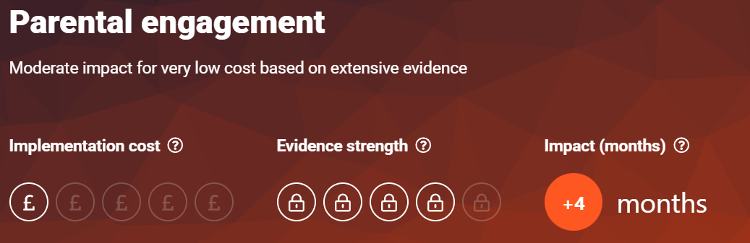 | 1,2,3,4
Breakfast clubs and  meal provision  Supporting children to access a school lunch  Nutrition education and cooking club  Food voucher scheme – school can refet directly | There is some evidence that providing free, universal, before-school breakfast clubs can benefit pupils by preparing them for learning or supporting behaviour and school attendance. | 4

Total budgeted cost: £22,103 (allocated Pupil Premium Funding £21,125.00)
Part B: Review of outcomes in the previous academic year

Pupil premium strategy outcomes
This details the impact that our pupil premium activity had on pupils in the 2024 to 2025 academic year.
Action | Intended outcome | Impact | Evaluation
LSA’s in classes of Pupil Premium children for at least half of the school day | To improve attainment in Phonics, Reading, Writing and Maths in all pupil groups | Year 6 SATS - One PPG child achieved greater depth in Reading and GPS and expected in Maths, another with additional needs made progress in all areas and achieved expected in Maths. | All classes had an LSA every morning.  School will focus on development of writing through EEF Literacy Tree trial, phonics interventions and Maths fluency.
Implementation of in-house SEN assessments | To identify key gaps in pupils’ learning and provide targeted, laser sharp therapies to close gaps and raise attainment | Targeted children across the school made progress in their learning. | This method will be continued as was effective for all pupils.  A focus on those who are ‘double disadvantaged’.
Subscription to TES develop programme for all staff including governors | Staff to feel confident in CPD for areas including PP and SEND | Staff report that online training access allows them to seek training straight away for anything needed to support PP children as well as others. | We use TES develop in line with other trust schools to share good practice and CPD
Nurture time given for individuals and groups with trained LSA’s, after referral | To provide support to children referred as needing nurture support | 3 fully trained staff fully trained embedded their practice. The children referred receive weekly sessions and have been accessing learning more readily and have strategies to support their emotional needs in and out of school | Mental health provision developed across the school with referrals to nurture or counselling depending on the needs of children.
ACES training | To develop staff understanding of ACEs and how these can impact on the children in our care. | Support staff all completed ACEs training through National College. | Wider understanding.
Targeted support
Action | Intended outcome | Impact | Evaluation
Lexia Reading Core5- | To support children with reading difficulties and close learning gaps  To complete free trial of Lexia programme to consider continued use depending on impact. | Additional independent learning in the morning on computers showed good engagement from children.  Individual children made good progress. | Trial period completed with successful results, so Lexia subscription continued beyond the free trial.  Teachers trained to continue and add use of additional Lexia lessons.
School BACP accredited counsellor with qualifications in working with looked after children and autism | To provide specialist support for children with social, emotional and mental health needs | The children have now ask see Lilly for drop in sessions as well as blocks of counselling which are organized. Counselling is established in school. | More children are requesting sessions. Next year we will be able to extend our offer to include another recently qualified counsellor.
Phonics play | To support parents in the learning journey of their child at home | Changes to school phonics scheme meant that additional support can be obtained from the resources associated with the scheme. | Not continuing with this subscription. Staff creating packs for phonics interventions – Twinkl Phonics scheme to be rolled out next year.
Nessy subscription | To support children with reading and spelling difficulties | The year 3 and 4 children who required additional phonics intervention found this programme engaging. It promoted independence in the morning and progress was evident. | Following the success of Lexia (part of EEF research), and links to other Trust secondary schools, focus for more children t access Lexia rather than Nessy or IDL moving forwards. Also, more children can benefit from this, rather than limited number of licenses.
Precision teaching | To develop specific spelling skills |  | To use approach again for specific children as required.
Time to Talk | To support communication skills. | This programme worked very well for some individuals, however other not as successful for other PP children due to additional needs related to Autism and language development. | To consider use of the programme again in the future based on needs of individual children.
Wider Strategies
Action | Intended Outcome | Impact | Evaluation
Healthy Minds Week planning, preparation and activities. ‘Know yourself, grow yourself’ 2025 | To improve the, mental wellbeing and aspirations of our pupils, with a particular focus this year on ‘Know Yourself, Grow Yourself’, supporting children to express their individuality and what makes them special. | The children were able to clearly identify aspects of their own lives, hopes and dreams. | Parent and pupil feedback.
Payment for clubs, trips and visits. Uniform. | For all Pupil Premium pupils to have the opportunity to access wider, enriching extra-curricular opportunities | Pupil Premium pupils attended a club or extra-curricular activities, including an SEN bowling event. | Continue to explore additional clubs and opportunities with different providers.
Access to breakfast club | To support attendance and arriving on time by giving paid access to the breakfast club provision | Improved attendance and lower rate of late starts.  Child/ren more settled as they begin their learning day | Strong impact for children who are also on CIN plans or TAF.
Swimming | To provide children with an opportunity to take part in physical activity and promote water safety. | This was particularly valuable for a child who had not had the opportunity to attend swimming lessons before.  A wonderful improvement in confidence over the course of the lessons, with support from teaching staff. | This will be reviewed based on the needs of individual children.

