Hey there! If your teacher has given you an assignment on Microsoft Teams, don't worry – it's super easy to do. Follow these simple steps to complete and submit your assignment.

Step 1: Log in to Microsoft Teams:

Open Microsoft Teams on your computer or device.
Log in using your school account (your email address will end with @hrps.me)

Step 2: Find Your Assignment:
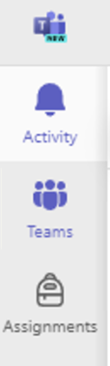
Look for the "Assignments" tab on the left side of the screen.

Click on it to see all your assignments.

Step 3: Select Your Assignment:

Find the assignment your teacher wants you to do.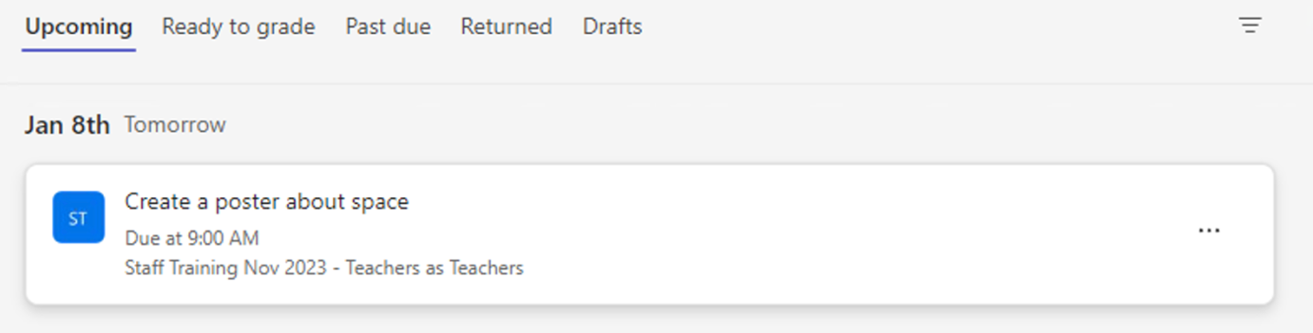
Click on the assignment title to open it.

Step 4: Read Instructions:

Your teacher will give you all the details you need to complete the assignment.
Read the instructions carefully so you know what to do.
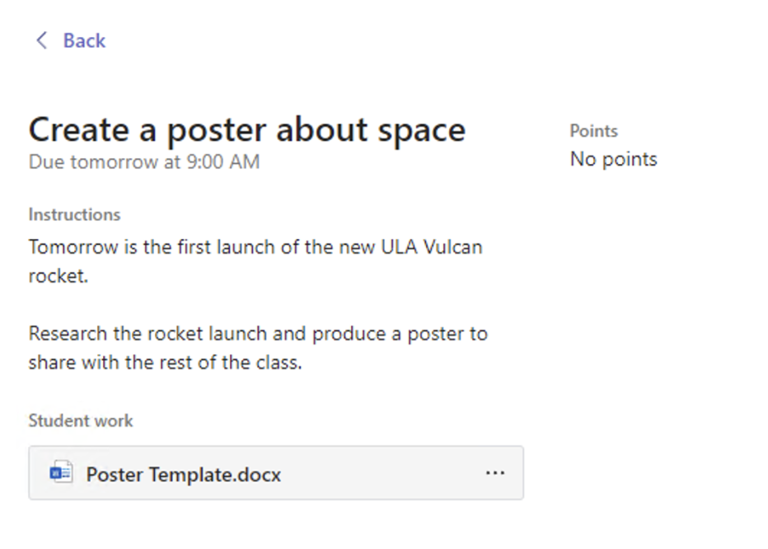

Step 5: Work on Your Assignment:

Use any attached files or resources to help you with your work.
If it's a quiz, answer the questions as best as you can.

Step 6: Save Your Work:

If you need to work on the assignment over time, make sure to save your progress.

Step 7: Complete the Assignment:

Finish all the questions or tasks your teacher has given you.

Step 8: Submit Your Work:

Before you submit, double-check to make sure you've answered everything and attached any files your teacher asked for.

Once you've completed everything, find the "Submit" button.
Click on it to send your assignment to your teacher.

Step 09: Confirm Submission:

After you submit, you might see a confirmation message. Make sure it says your assignment was sent successfully.

And that's it!
You've successfully completed and submitted your assignment on Microsoft Teams. If you have any questions, don't hesitate to ask your teacher for help. Great job!

