All about Me

Please stick a photo here

My name is:

My Family
Can you draw some pictures of your family?

I have brothers aged

I have sisters aged

I have a pet ______________________

Independence Skills
What can you do?
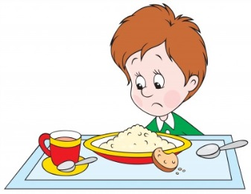  Eat with a knife and fork |  |  | 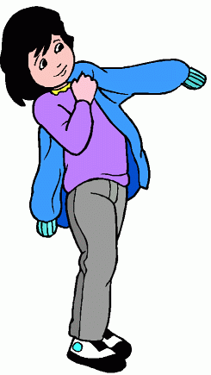  Put on my coat |  |  | 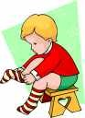  Put on my socks
Yes | No | Almost | Yes | No | Almost | Yes | No | Almost
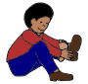  Put on my shoes |  |  | 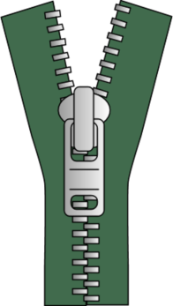  Do up zips |  |  | Do up buttons
Yes | No | Almost | Yes | No | Almost | Yes | No | Almost
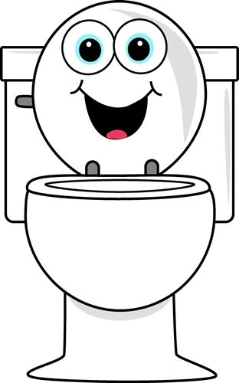  Go to the toilet on my own |  |  | 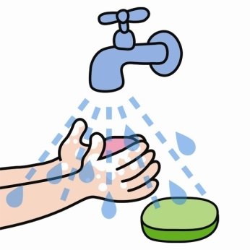  Wash and dry my hands |  |  | 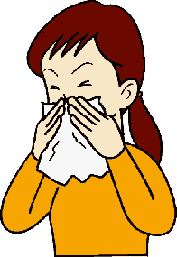  Blow my nose
Yes | No | Almost | Yes | No | Almost | Yes | No | Almost

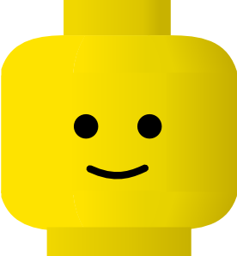
I am happy when:

I am upset when:

Pre-school setting

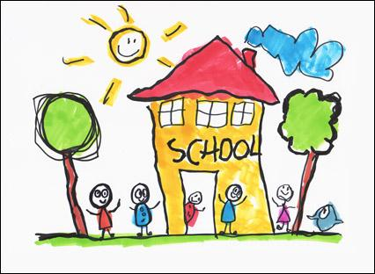

I have been to playgroup/nursery/childminder
I went to
At playgroup/nursery I liked to
When I start school I am looking forward to:

Thank you for telling us all about you!

About My Child
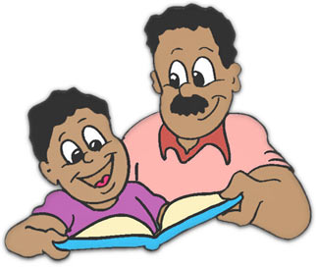

Perhaps there are other things you as a parent would like us to know. You may wish to make a comment about your child's readiness for school, any health issues (eg allergies or special medication), family circumstances (such as a new baby or other changes in the family).

